**SHELL SCRIPT ASSIGNMENT**

1. Create a script named “myscript” in current directory to do the following.

a) display “hello user”

b) list files in current directory

c) name of logged in user

d) date

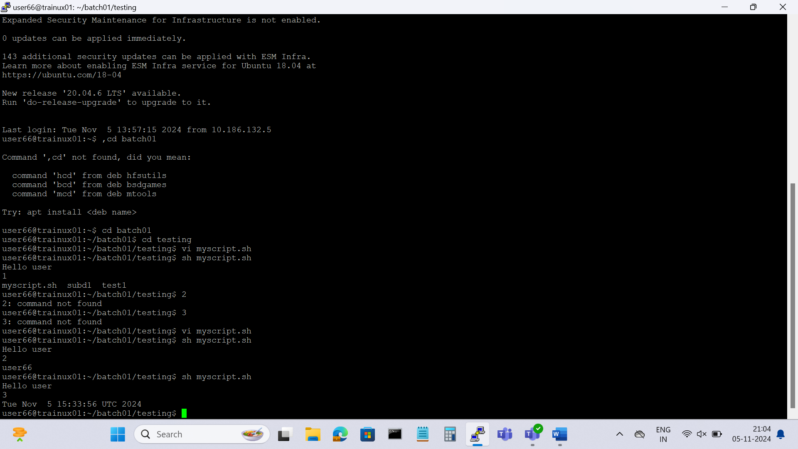

2. Add execute permission and Run the script from

a) current directory

ans: chmod a+x myscript.sh

3. Create a subdirectory named “test”

4. Change to “test” directory. Run the script “myscript” [Hint: You will have to update PATH to include the directory containg script to run script from any location].

Optional Assignments:

1. Considering command line arguments are accessible using $<position> i.e

$0- for first argument

$1- for second argument…

write a shell script to concatenate all command line arguments using ‘_’ and display it as a single string.

Refer example below

$>./myscript.sh ABC DEF

Output:

ABC_DEF [Refer <http://linuxcommand.org/lc3_wss0120.php>]

Ans:

. cd test

sh <path of myscript.sh>

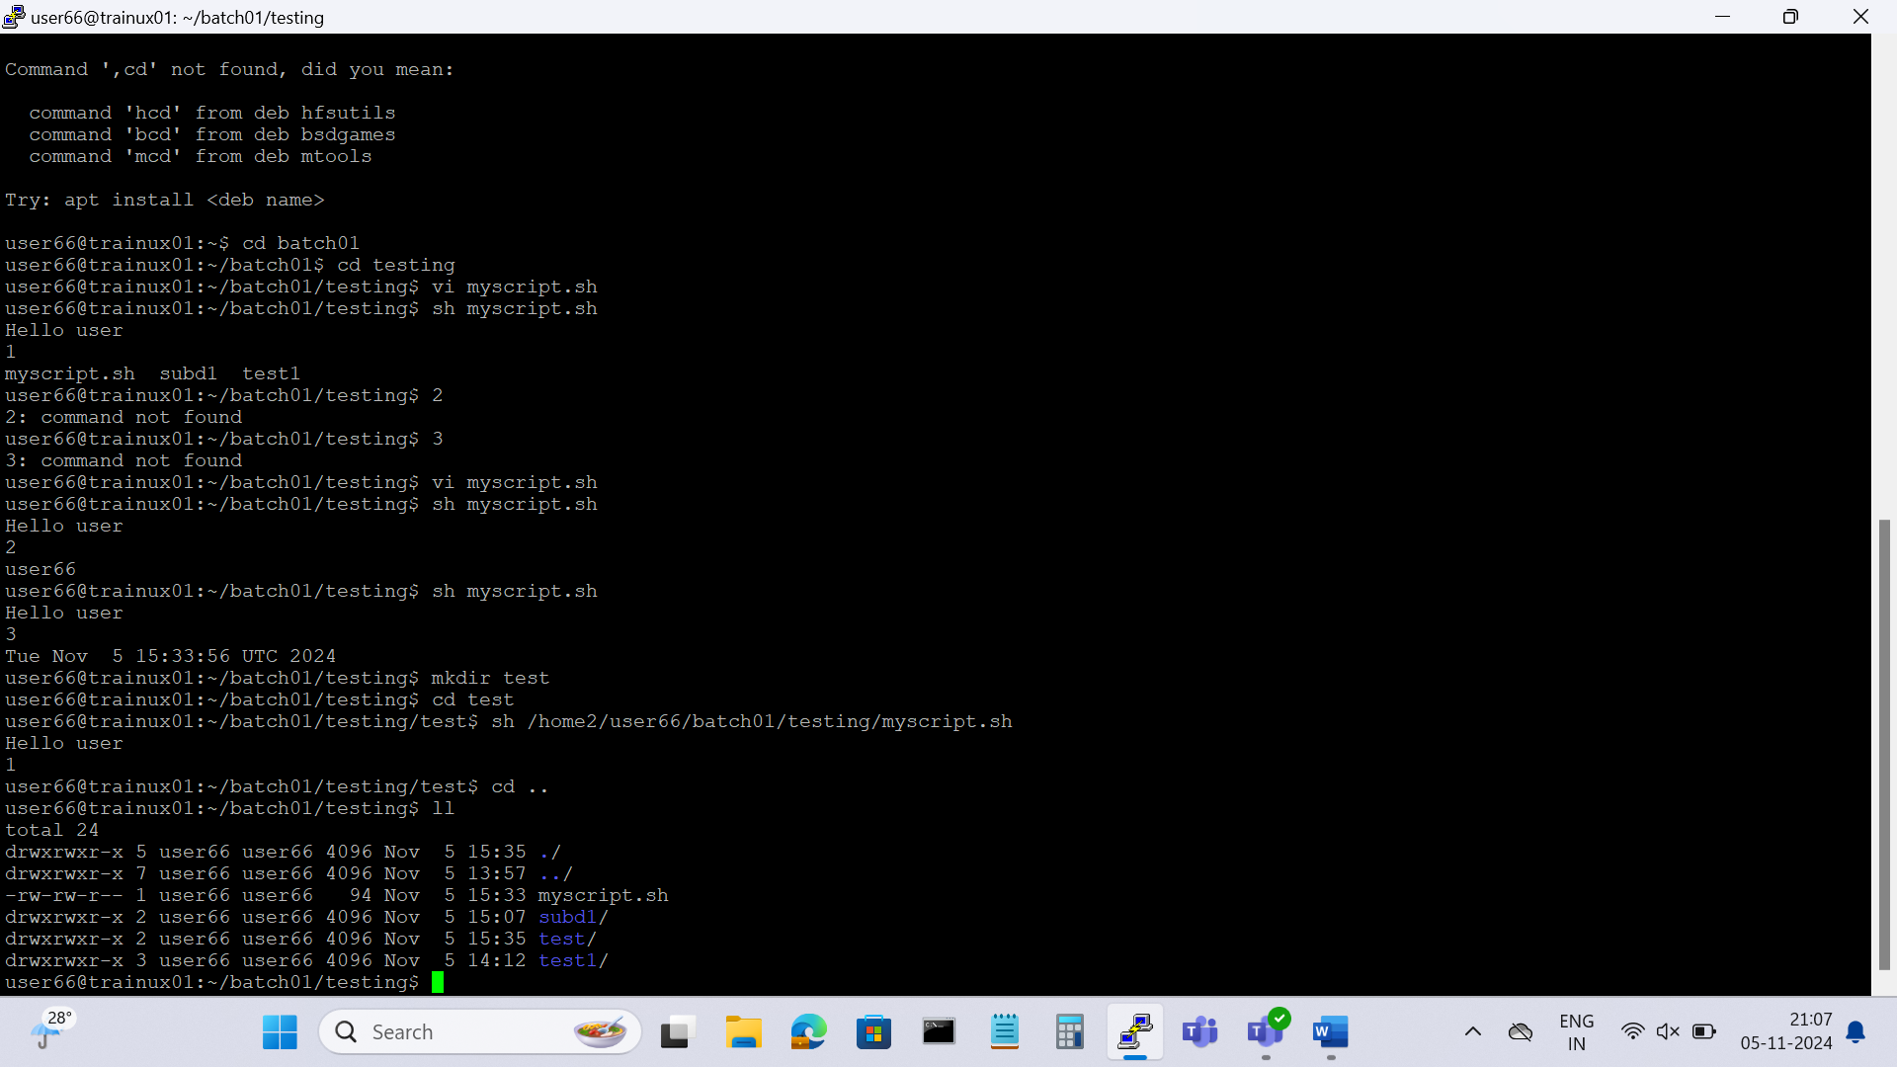

**FILE DIRECTORY**

Mandatory:

1. Search and display all *.c and *.h files in all subdirectories starting from current directory

2. Search and display all directories in all subdirectories starting from current directory

3. Search and display all files with permissions only rw with user and execute permission for others

**GREP ASSIGNMENT**

Mandatory:

1. Use any .c file. Using grep command extract and display

a. all lines beginning with #include with line numbers

b. display all lines which do not begin with #include

c. display the line number of main()

d. extract all lines containing characters of opening and closing parathesis {(,))

2. Perform the above operations on a set of *.c files